**Creating Microservices for account and loan**

Step 1: i have created a spring starter project for 1st microservice i.e account

Below is the screenshot: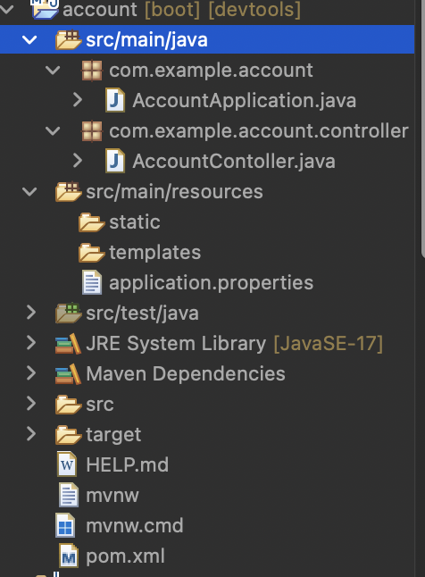

Then i have created controller package:

Inside AccountController class has been created below is the code:

package com.example.account.controller;

import org.springframework.web.bind.annotation.GetMapping;

import org.springframework.web.bind.annotation.PathVariable;

import org.springframework.web.bind.annotation.RequestMapping;

import org.springframework.web.bind.annotation.RestController;

*@RestController*

*@RequestMapping*("/accounts")

public class AccountContoller

{

*@GetMapping*("/{number}")

public Account getAccountDetails(*@PathVariable* String number)

{

return new Account(number,"savings",234235);

}

static class Account{

private String number;

private String type;

private double balance;

public Account(String number, String type, double balance) {

this.number = number;

this.type = type;

this.balance = balance;

}

public String getNumber() {

return number;

}

public String getType()

{

return type;

}

public double getBalance() {

return balance;

}

}

}

Then i have successfully executes by clicking on run as spring boot app then the output on the console is  
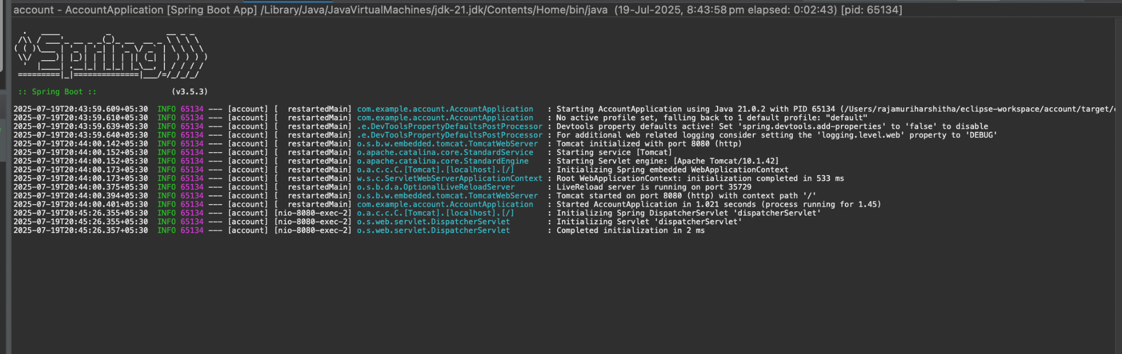

Step 3:by using postman api i have executed the get method here is the required output:

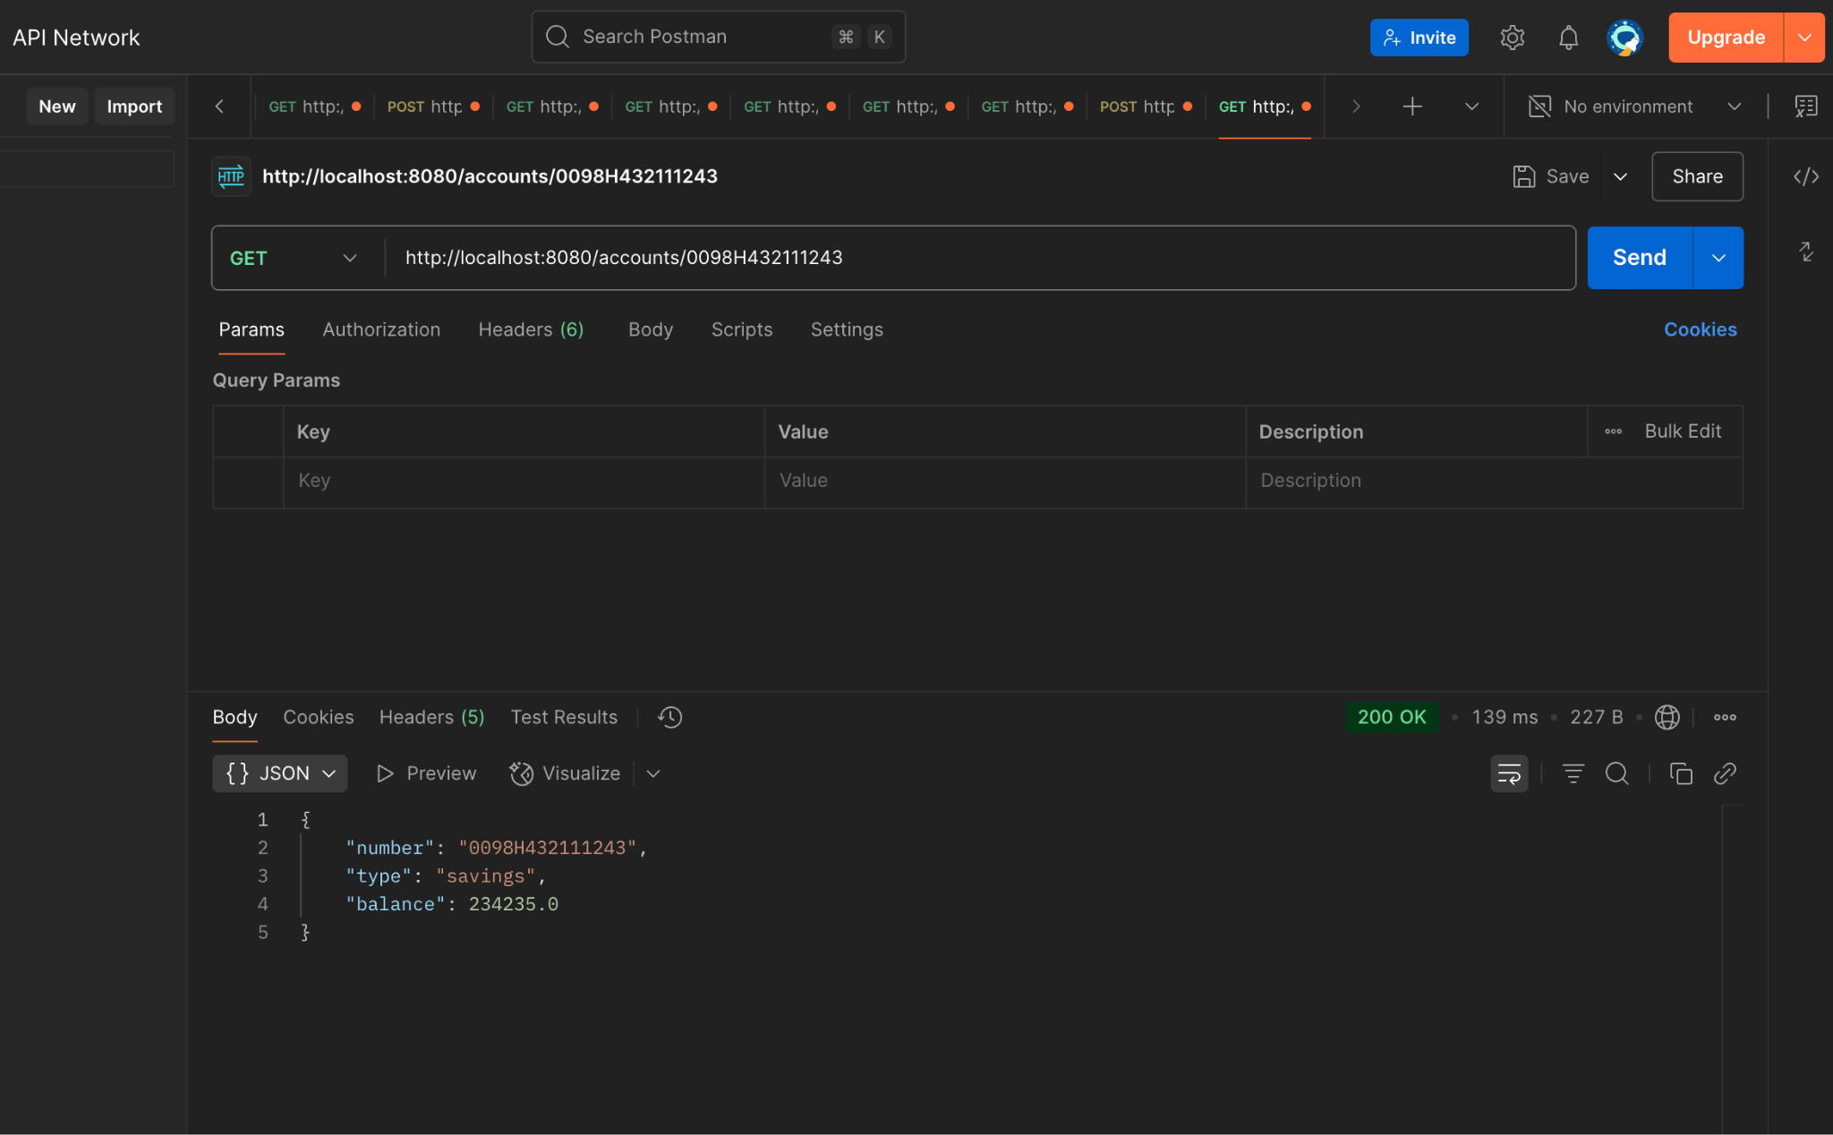

Step 4:  
According to the problem statement i have then created another independent required microservice that is mentioned in handson related to bank i.e Loan   
By following the same procedure i have created a spring starter project named Loan  
Here is the project folder structure 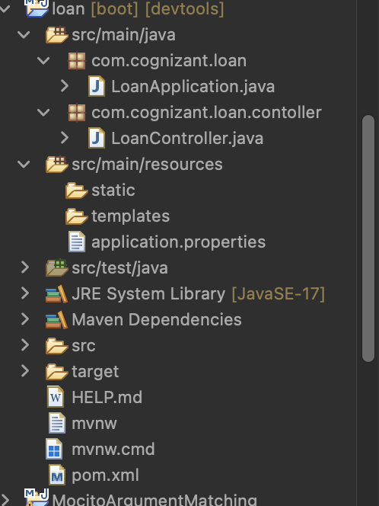

package com.cognizant.loan.contoller;

import org.springframework.web.bind.annotation.GetMapping;

import org.springframework.web.bind.annotation.PathVariable;

import org.springframework.web.bind.annotation.RequestMapping;

import org.springframework.web.bind.annotation.RestController;

*@RestController*

*@RequestMapping*("loans")

public class LoanController {

*@GetMapping*("/{number}")

public Loan getLoanDetails(*@PathVariable* String number)

{

return new Loan(number,"car",400000,3258,18);

}

static class Loan{

private String number;

private String type;

private double loan;

private int emi;

private int tenure;

public Loan(String number, String type, double loan, int emi, int tenure) {

this.number = number;

this.type = type;

this.loan = loan;

this.emi = emi;

this.tenure = tenure;

}

public String getNumber() { return number; }

public String getType() { return type; }

public double getLoan() { return loan; }

public int getEmi() { return emi; }

public int getTenure() { return tenure; }

}

}

Application.properties

spring.application.name=loan

server.port=8081

I have changed the port number because by default it runs in 8080 since we have already written microservice  
For multiple microservices we need to change the port number hence we use 8081

After successfully compiling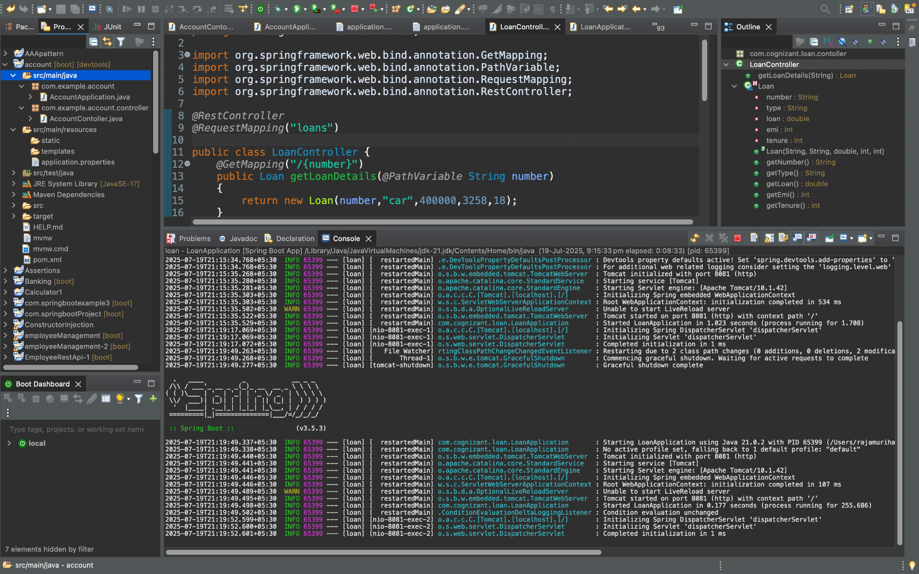

Next step:

After opening the app we need to open postman and hit the below url

* URL: http://localhost:8081/loans/H00987987972342

This is the required output

